Course Code – Course Name
Report name
Group name
Student name 1 – Student ID
Student name 2 – Student ID
Student name 3 – Student ID
Month Year

Table of Contents
Abstract 3
1 Introduction 4
2 Details on the report template 5
2.1 Font and layout 5
2.1.1 Figures 5
3 Details on the references section 6
References 7

Abstract
An abstract is a brief summary of the report. Its main purpose is to provide readers with a concise
and accurate overview of the content of the paper, enabling them to quickly understand the key points and decide whether to read the full text.
Overall, an abstract should be clear, concise, and well-written, with a focus on providing the reader
with the most important information about the report.

Introduction
An introduction is the opening section of a report. Its purpose is to provide the reader with an overview of the topic and to set the tone for the rest of the work. The content of an introduction typically includes the following elements:
- Background Information: This section provides context and background on the topic, explaining why it is important or relevant. It should include in-line citations from external sources that help the reader understand the significance of the topic.
- Literature review: the state-of-the-art information should be given in this section. References from journal articles should be mentioned. A good literature review usually consists of at least 12 references.
- Problem statement: the current state of the research may be satisfactory, but improvement can always be explored, for example applications of an existing technology in a different area. The student is invited to state one topic that could be beneficial for the society.
- Contribution: the student is invited to describe shortly a way do deal with the problem statement.
- Structure of the report: This section outlines the scope of the work, explaining what will be covered and what will not. It may also provide an overview of the structure of the work.
Overall, an introduction should be concise, engaging, and informative, setting the stage for the rest of the work and enticing the reader to continue reading.

Details on the report template
A title should always be followed by a small or medium paragraph that explains the content of the section. The current section presents what the authors should be aware of while writing a report.

Font and layout
Most of the students will underperform in their report because of inconsistency in the layout of their report. One should know that just a grammar error or inconsistent font in a resume is enough to rule a candidate out from a job interview. Here are the recommendations for a report:
- Use the “Styles” available in the “Home” tab for title of each section and subsection to generate a structured report. Do not forget to update the table of contents
- The text should be justified left and right (CTRL+J shortcut on a Windows computer)
- For the font of the core of the text, Arial 11 with 1.5 spacing has been used. Please use it as well.

Figures
Figures are an important part of a report. The guidelines for figures are:
- All figures require a caption. All figures must be commented and cited in the text.
- All figures must be readable. Copy-and-paste of a low-resolution figure with unreadable text is unacceptable.
- Do not wrap text around figures. Centered figures on top or bottom of pages are appreciated.
Figure 1 shows the forces acting on an airfoil. Even though repetitive, one must write a caption about the figure and an additional text, which refers to the figure. This allows the reader to connect rapidly from the text to the image. Notice that the figure is centered, readable, and located at the bottom of the page.
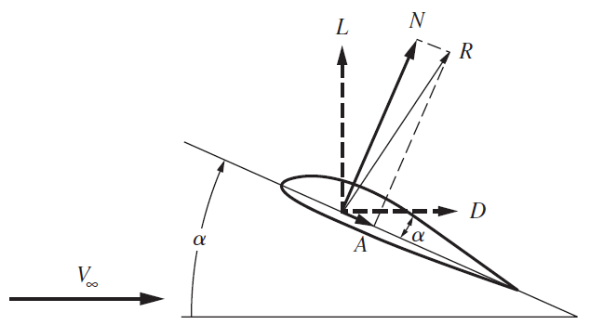
Figure 1: Forces acting on an airfoil

Details on the references section
References usually seem unimportant for students. However, when you are creating a piece of art, drawing, or research contribution, it is important to be awarded and recognize for your work, which is why the reference section should be well-presented and completed. For instance, if you are interested in robotic research for human-robot interaction, there are fantastic resources given by the Disney research group on organic movement and animatronics [1].
Be careful that the reference section is updated and appear in the chronological order in appears in the report. It should NOT be alphabetical, or chronological in terms of year of publication. For instance, this is another in-line citation about robotic research on the Gough-Stewart platform, which is useful for flight simulator [2].

References

[1] | S. Coros, B. Thomaszewski, G. Noris, S. Sueda, M. Forberg, R. W. Summer, W. Matusik and B. Bickel, "Computational design of mechanical characters," ACM Transactions on Graphics, vol. 32, no. 4, pp. 1-12, 2013.
[2] | K. Wen and C. M. Gosselin, "Forward Kinematic Analysis of Kinematically Redundant Hybrid Parallel Robots," Journal of Mechanisms and Robotics, vol. 12, no. 6, 2020.

